Java Installation

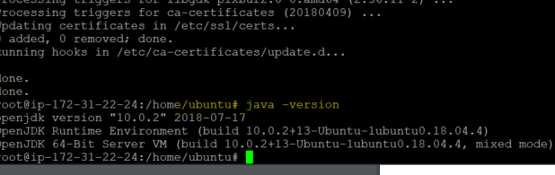

Jenkins installation

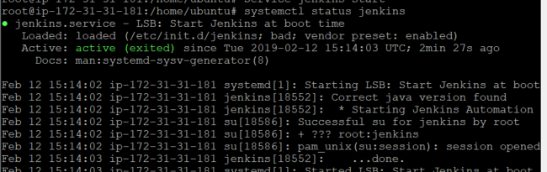

Accessing Jenkins from port8080

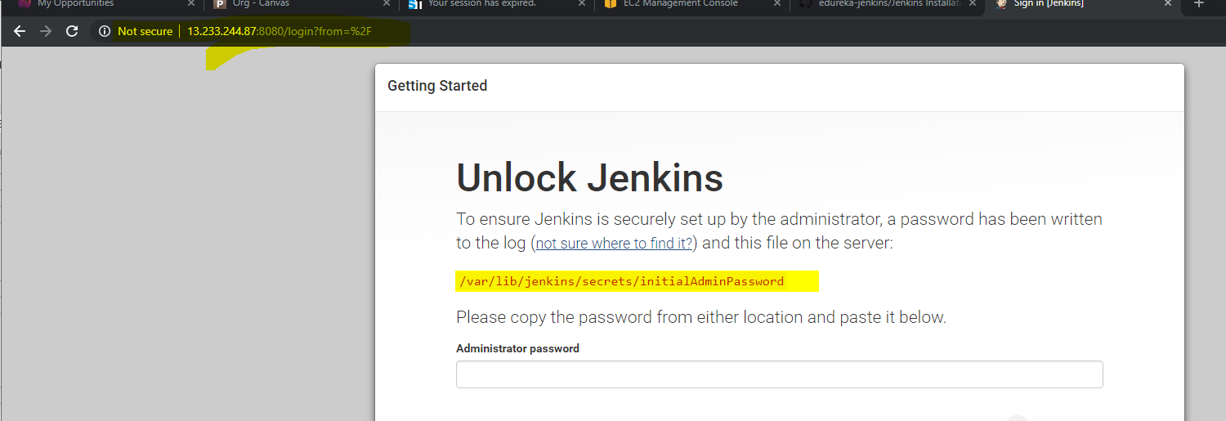

Installation of Default plugins

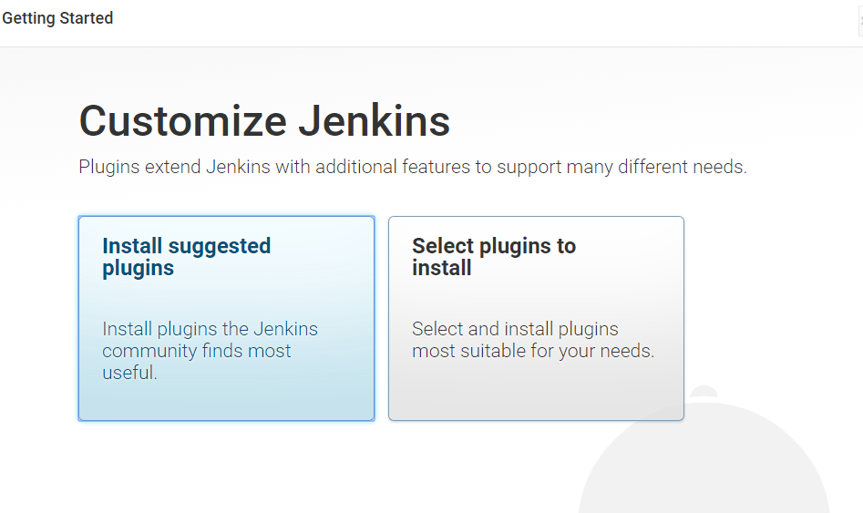

Creating Admin user

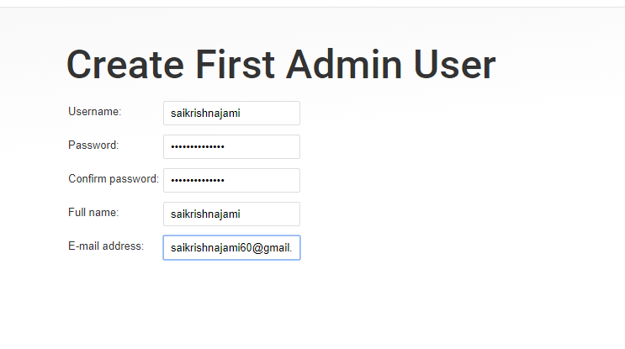

Default Global user settings

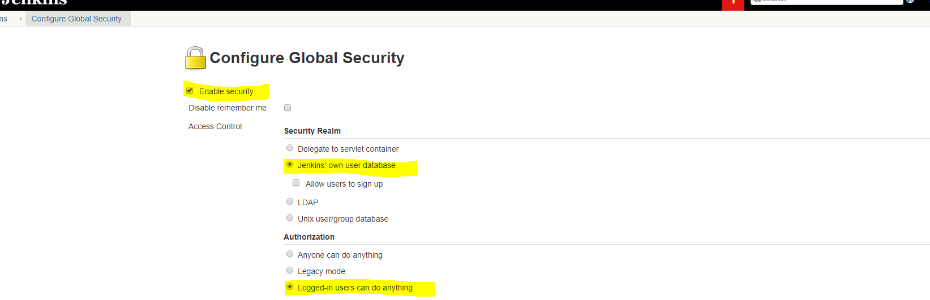

Installed role based Authorization plugin for controlling and setting permissions.

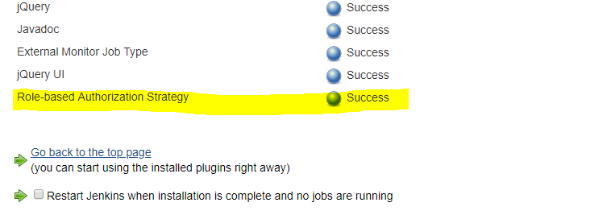

Enabled Role based Authorization in Global security settings

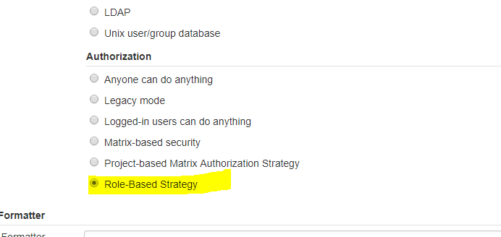

Created new user

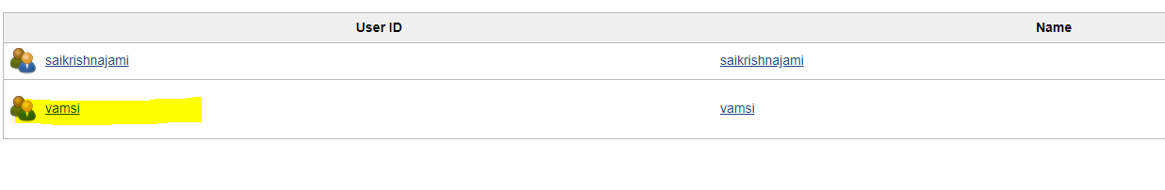

Under Manage roles, created new role and gave only readonly access to jenkins

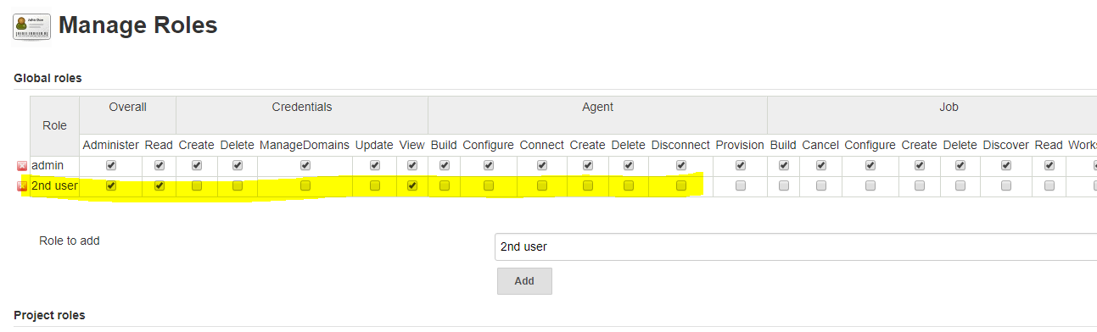

Gave only Read only access to user vamsi

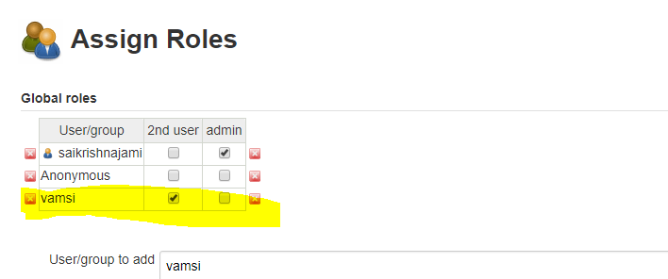

Installed all the default plugins for Integrating with Jenkins

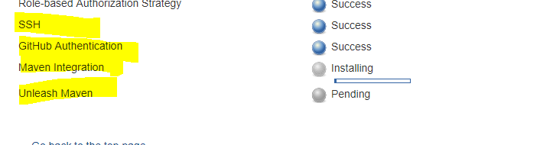

Installing Build Pipeline Plugin

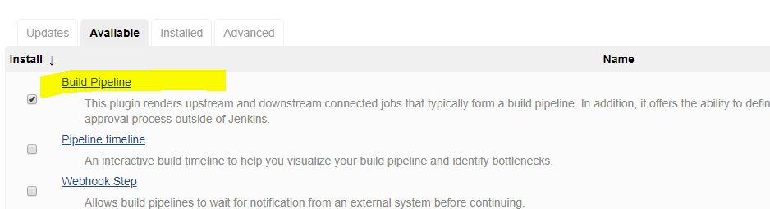

Configuring Email with Jenkins

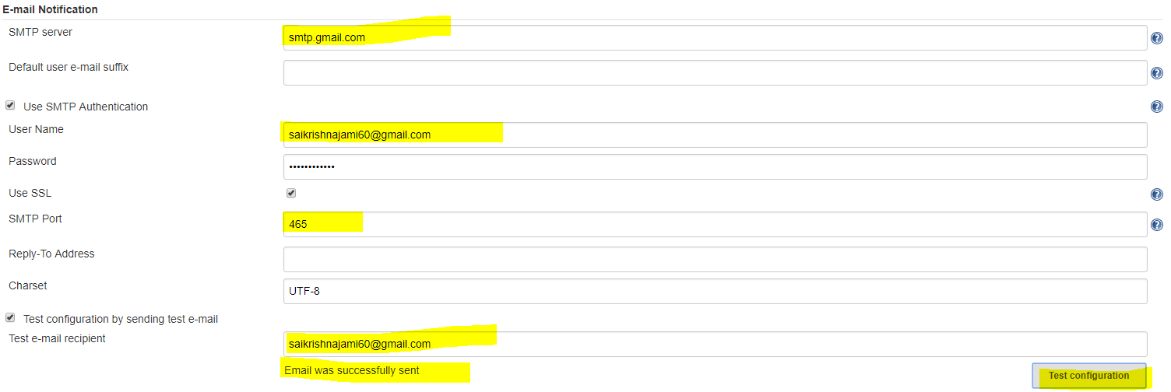

Created Build Pipeline Job

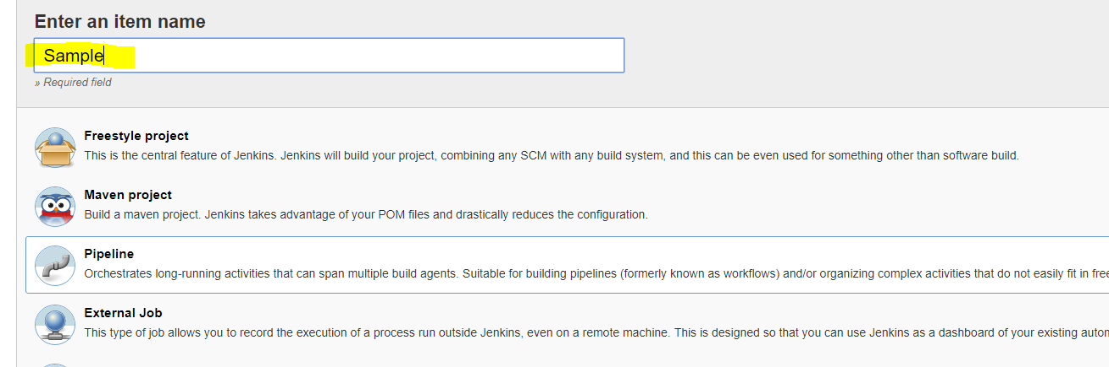

Configured sample maven project from git repository and Enabled POLL SCM for triggering the builds

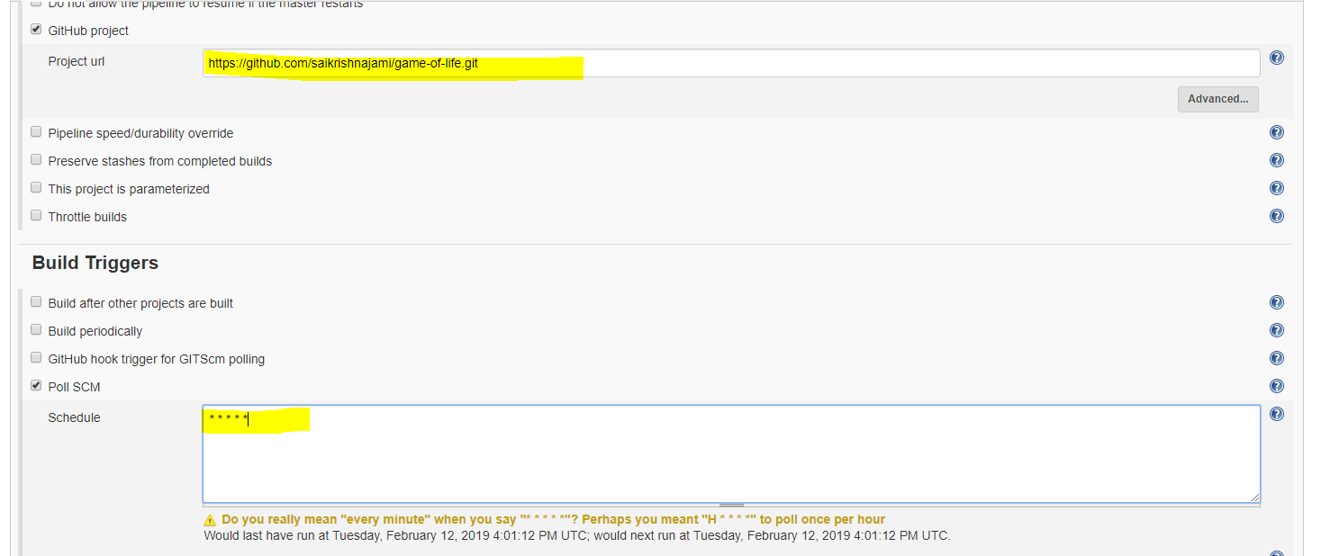

Configured maven in Global tool configuration

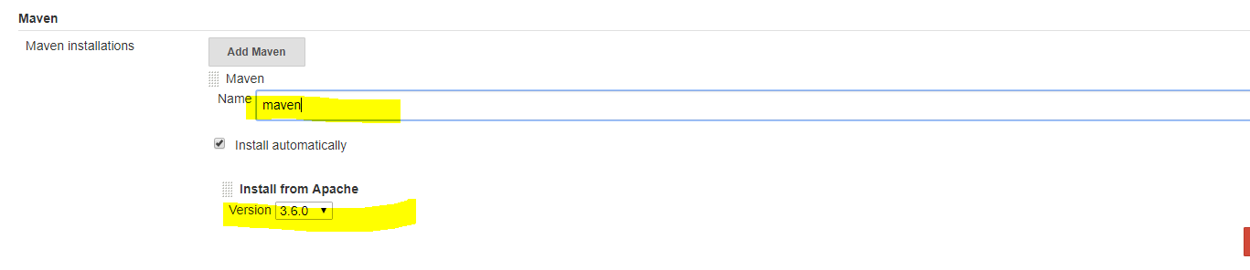

Building the code using maven

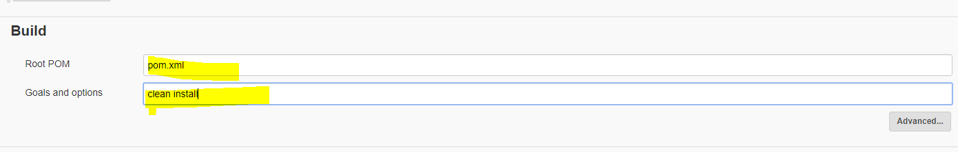

Enabled Email Notification for failed builds

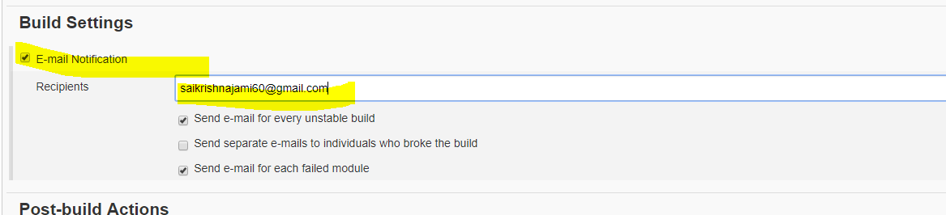

Build got failed and automatic email has been sent

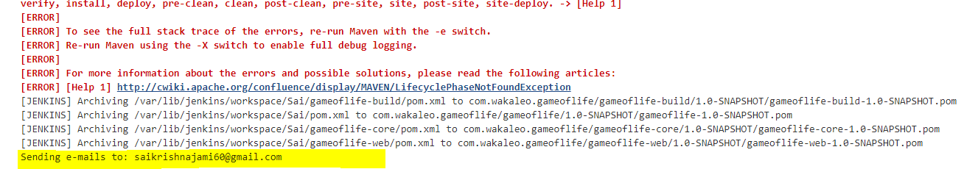

Configured Webhooks in Git repository for Jenkins URL

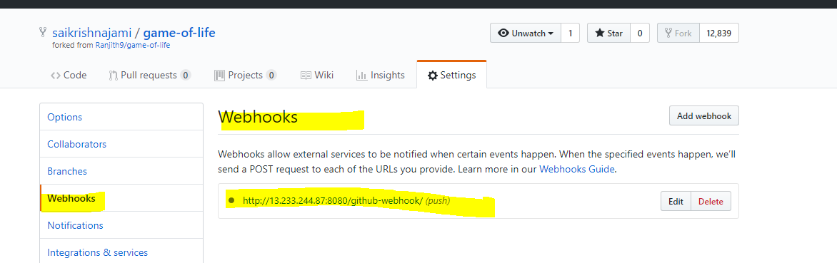

After making changes in Github code, Automatically build has been triggered in Jenkins.

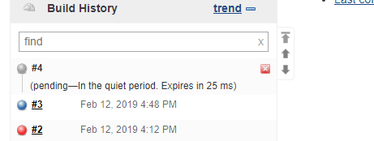

Created the slave in Manage Nodes and called it as QA Environment

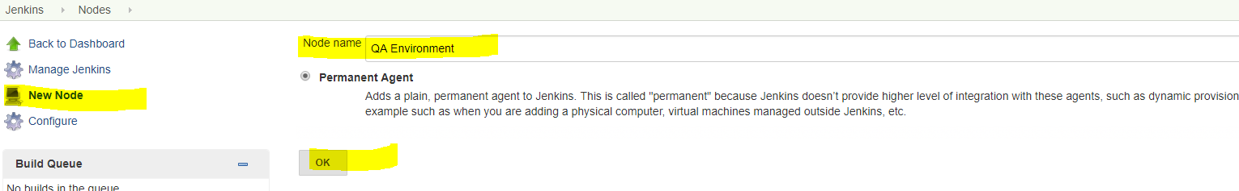

Creating Upstream and Downstream jobs and storing the build results in JJROG Artifactory

